1. 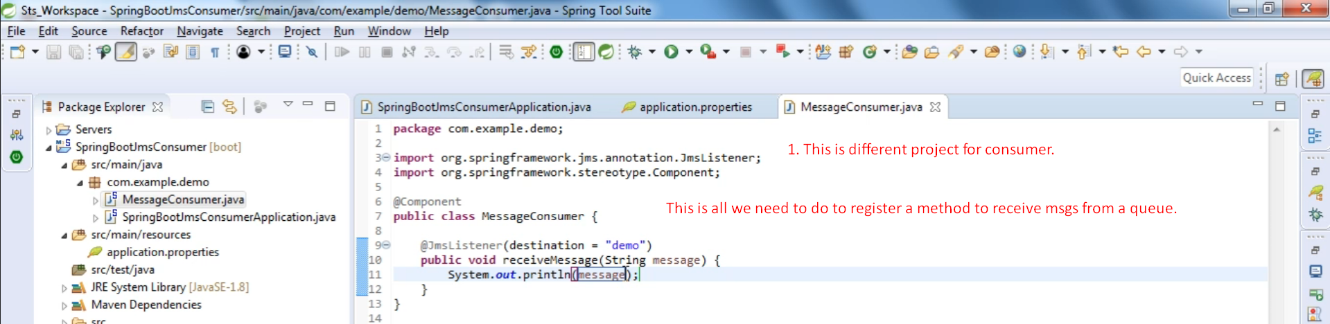
2. Graphical user interface, text, application

   Description automatically generated
3. Graphical user interface, text, application

   Description automatically generated